**Exercise Aim**

The aim of this exercise is to evaluate company X’s Road network in Rwanda to ensure that farm plots are accessible for delivering inputs. The files and the final outputs of the exercise are attached in the folder containing this report.

This exercise involves performing an accessibility analysis for optimization of transportation services and resources distribution. It is divided into 3 major areas:

1. Map
2. Analysis
3. Findings

Software used:

**ArcGIS Pro** – This GIS software is versatile in analyzing GIS data, allowing for the addition of basemaps with easily accessible analysis tools. It is also the GIS software that I am most comfortable with.

**Microsoft Word** – For the preparation of this report

**Map**

The first step in achieving the final map is loading the fields data and the downloaded OSM roads data to ArcGIS pro. For each vector dataset, the data was projected to UTM projection system; coordinate system WGS 1984, UTM Zone 35S (For Rwanda, near a town called Nyanza) – EPSG code 32735. This is illustrated in figure 1 below.

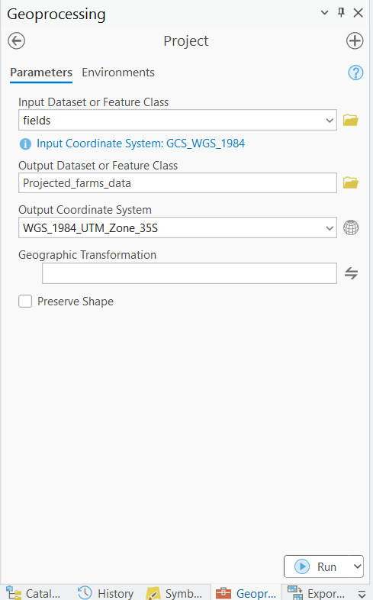

Figure 1: Data Projection

The next step was selecting the roads falling under the primary category. This was achieved through the **Select By Attributes** tool. The criteria applied was SELECT the hotosm_rwa_roads_lines_shp WHERE highway IS primary or primary_link. The resulting selection was exported and saved as “Primary _road_category_only.shp”. Figure 2 below shows the process used to select the primary roads.

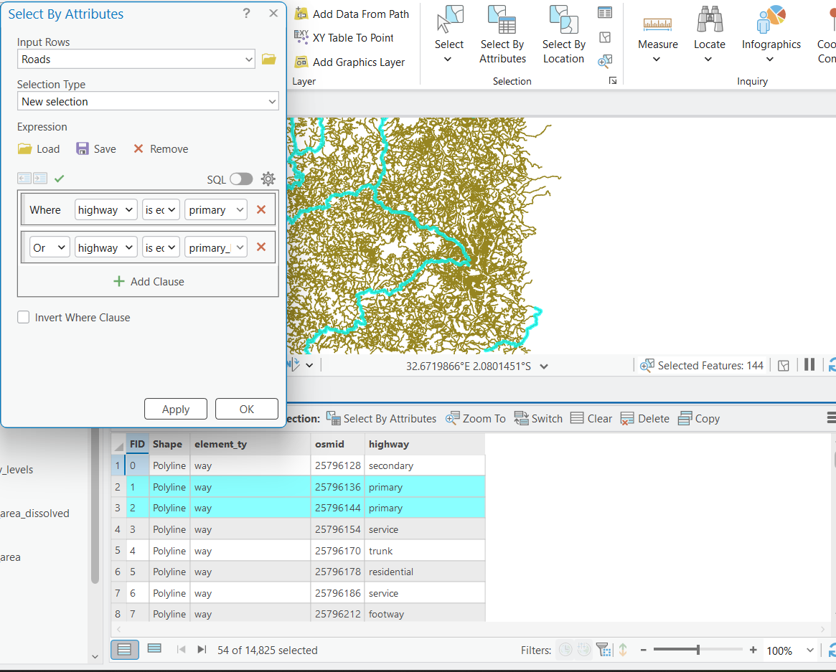

Figure 2: Select Primary Roads by Attribute

To analyze the accessibility level of each plot based on distance to the nearest primary road, the **buffer** tool was used. In our case since our interest was visualizing the plots more than 2 kilometres from the nearest primary road; the buffer tool parameters were defined as shown in figure 3.

**Buffer** **tool**: is a GIS analysis tool that creates buffer polygons around input features to a specified distance.

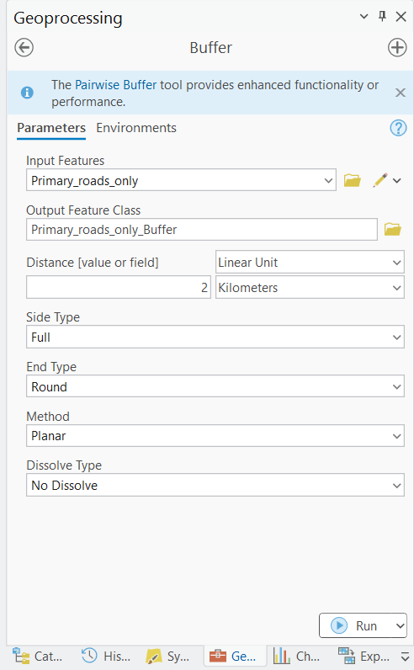

Figure 3: 2 Km Buffer

The **Dissolve** tool was then used to dissolve the overlapping polygons generated in the step above for the purpose of ensuring that we have one single representation of the accessibility area, within 2km of the primary road. Its implementation is as shown in figure 4 below:

**Dissolve Tool:** A Data Management tool used to aggregate features based on specified attributes.

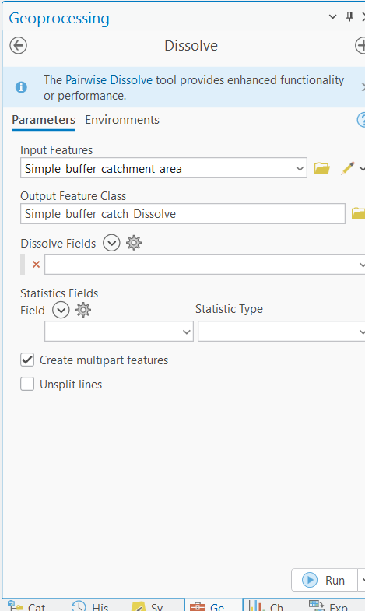

Figure 4: Dissolve Tool

**Analysis**

To find the farms that are beyond the 2 kilometres buffer area of the primary roads, use the **Select By Location** tool to perform the inverse intersection between the buffer and the farm fields. This is as illustrated in figure 5 below:

**Select By Location tool:** A GIS Data Management tool that allows the user to select features based on a spatial relationship to features in another dataset.

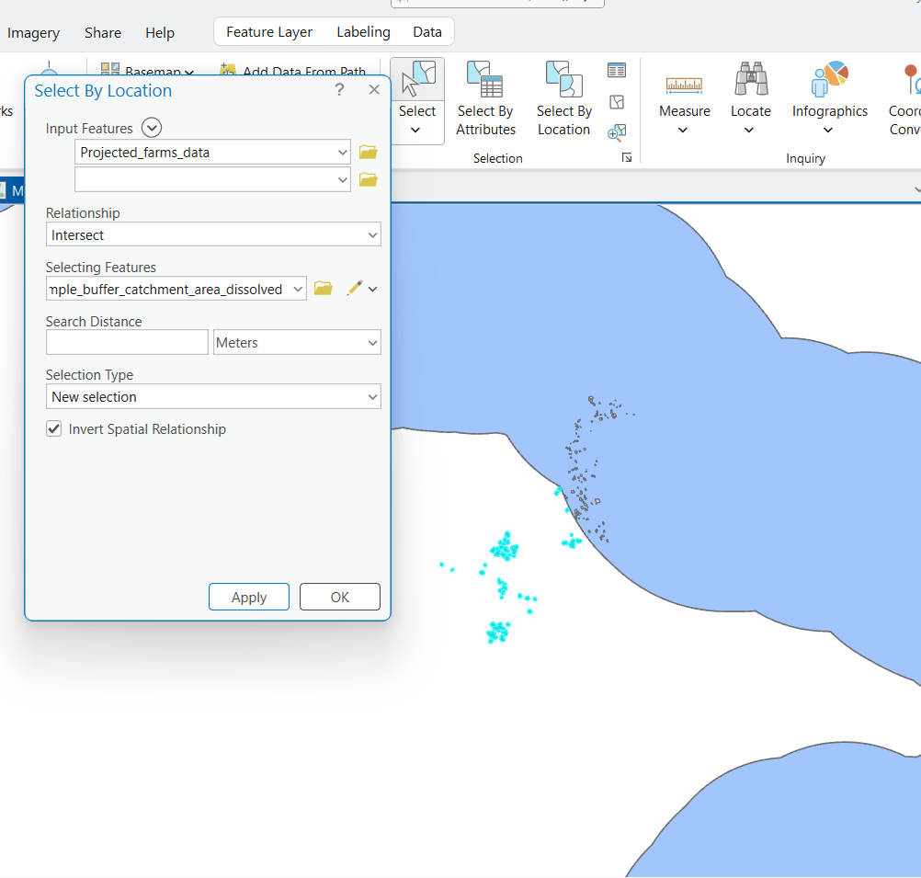

Figure 5: Features beyond 2 Km

The selected features (highlighted in blue) represent the farms beyond the 2km buffer cut-off.

The next step was to export the selected features and name the layer appropriately. The count of farms located beyond the 2km buffer from the attribute table is as shown in figure 6 below. There are **90 farms** fields located beyond the 2km buffer.

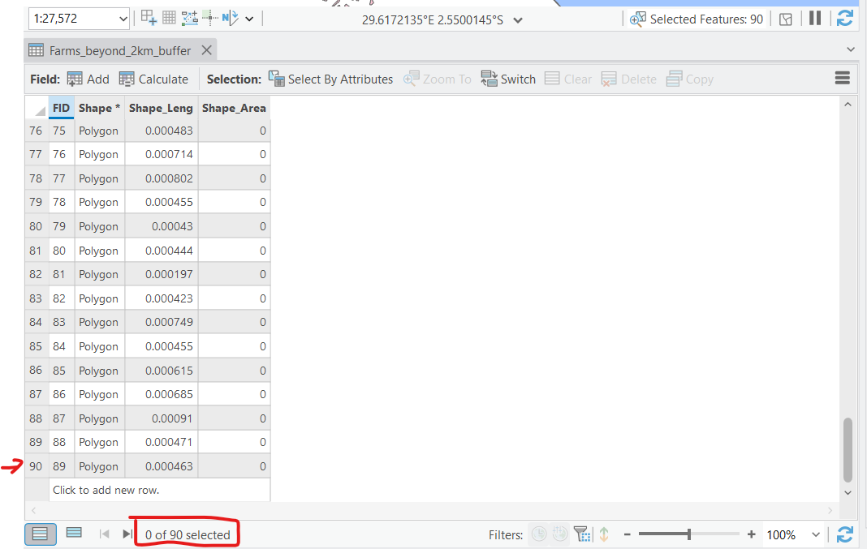

Figure 6: Farms Beyond the 2 Km Buffer

To compute the area of farms beyond the 2 kilometre buffer, I first created a new field name “Farm_Area” of fload data type, and then save the newly created field, which will be used in the calculation of the area of each farm. This process is as illustrated in figure 7 below:

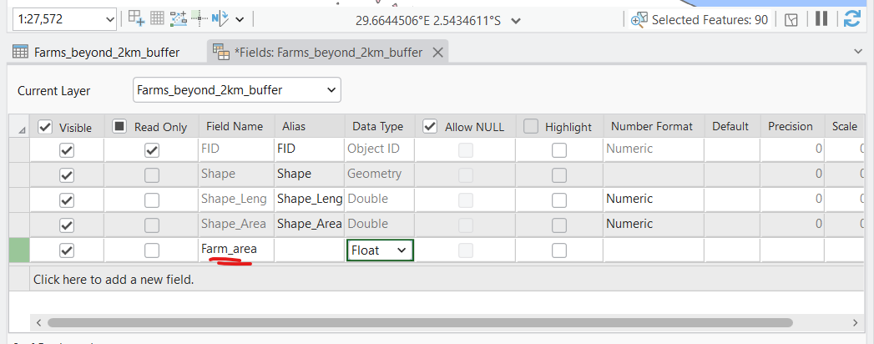

Figure 7: Create field for area calculation "Farm_area"

The final step is to calculate the area of each field, which is calculated through the **Calculate geometry tool.** To compute the area of the farms selected the newly created field “Farm_area” and right click then click calculate geometry. This computes the area of each farm field based on the shape property of the features. The area, in square metres is populated in each respective rows in the attribute table. This step is as shown in figure 8.

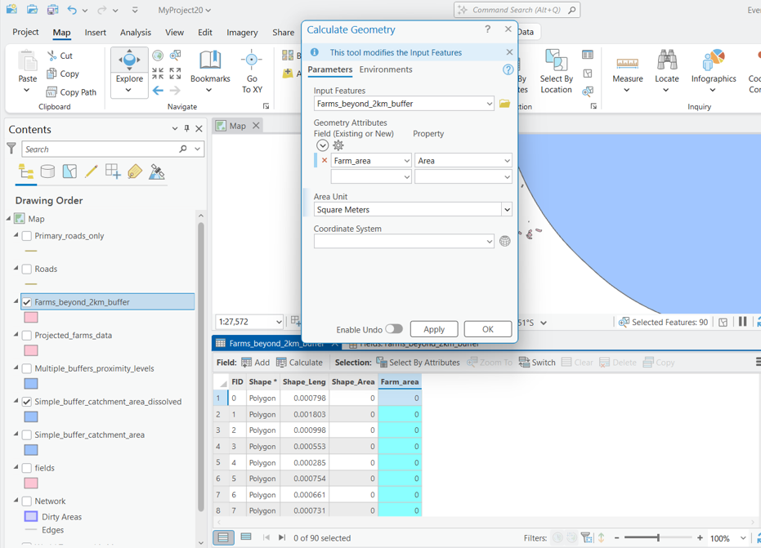

Figure 8: Calculate Geometry of Farm_area field

The summation of the areas is then obtained by exploring the statistics of the “Farm_area” field. Open the attribute table, then right click and explore statistics of the “Farm_area” field as shown in figure 9 below. The total area of farms beyond the 2 Kilometre buffer is **35527.595139 square metres** which is equal to **3.5527595139 Hectares** **(3.5528 Ha).**

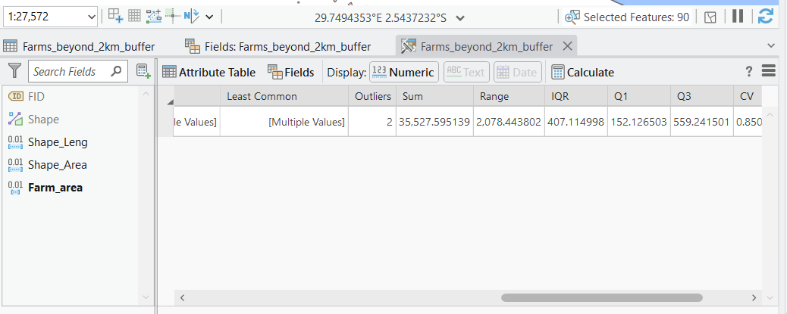



Figure 9: Total Area through Explore Statistics

**Final Map**

Here is a snippet of the final map generated.A multiple buffer to delineate areas within 2 km intervals was used to show the farms that fall within different zones.

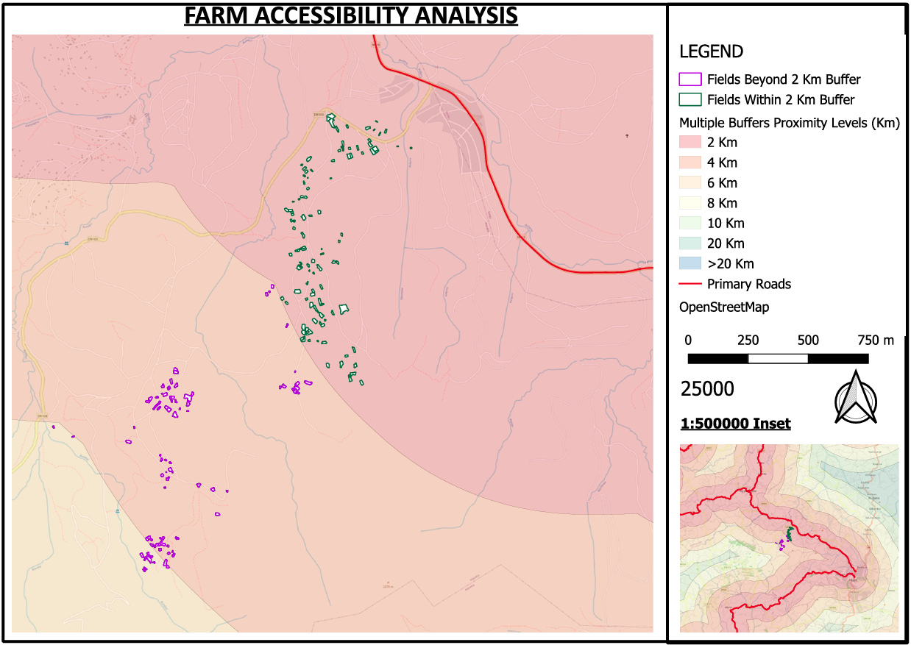

**Alternative Approaches for Generating a 2 km Catchment Area**

Instead of a **simple buffer**, which assumes **straight-line distance**, you can use **Network Analysis (Service Area) and Cost Distance Analysis** for a more **realistic catchment area** based on road networks and terrain constraints.

**Network Analysis (Service Area)**

**Uses road networks to define areas reachable within 2 km of travel distance or time.**

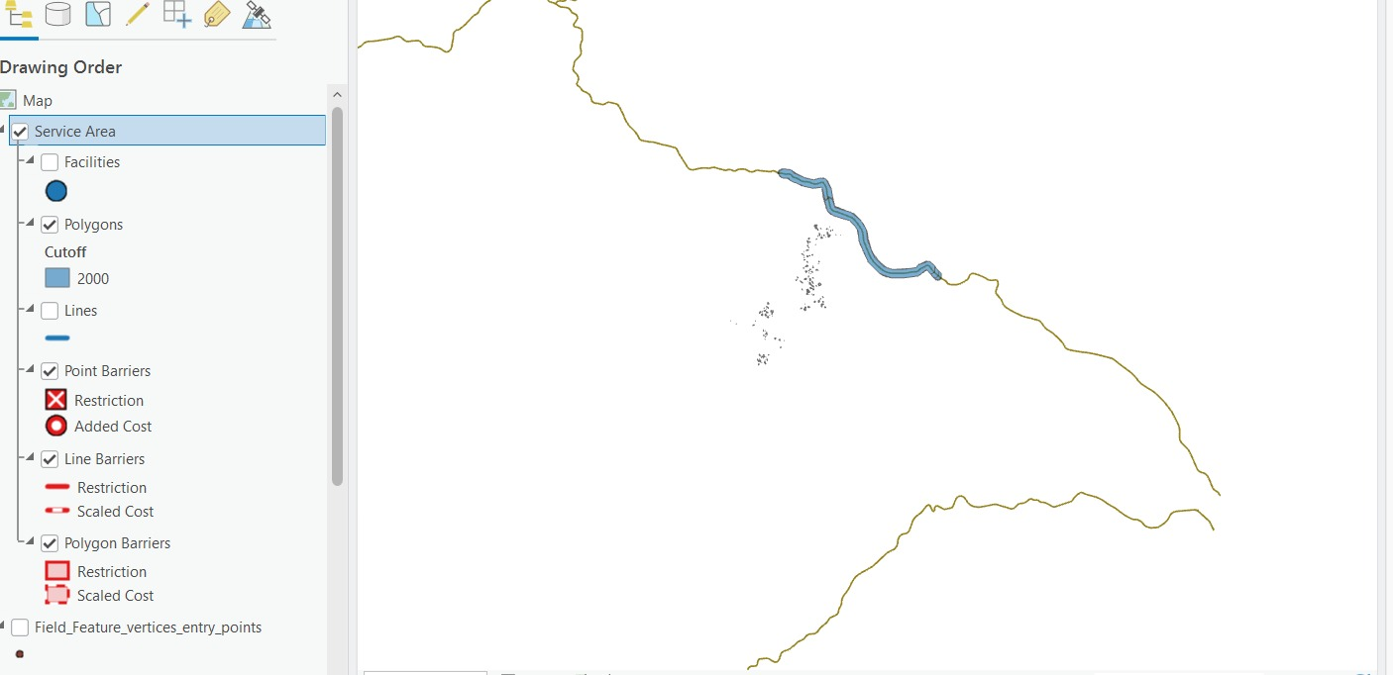

Figure 10: Network Analysis

**Pros:**

* More **realistic** than buffers since it considers the **road network**.
* Allows **custom travel constraints** (e.g., road types, speeds, one-way streets).
* Can generate **isochrones** (catchments based on travel time).

**Cons:**

* Requires **a good-quality road network dataset** (e.g., OpenStreetMap).
* Complex **setup and processing** compared to simple buffering.
* May not account for **off-road accessibility** (e.g., walking through fields).

**Cost Distance Analysis**

**Creates a catchment based on travel "cost" rather than simple distance (e.g., elevation, land cover, road type).**

Figure 11: Euclidean Distances

**Pros:**

* **More flexible** than network analysis – considers off-road travel.
* Works well in **rural areas** where road networks are sparse.
* Can integrate **multiple factors** (e.g., slope, land cover, road quality).

**Cons:**

* More **computationally intensive** than buffering and network analysis.
* Requires **raster datasets** (elevation, friction surfaces).
* Output depends on **accurate cost factors** (e.g., walking speed on slopes).